Stage 2 – Cultivating Potential
Designed by Rocky Perillo
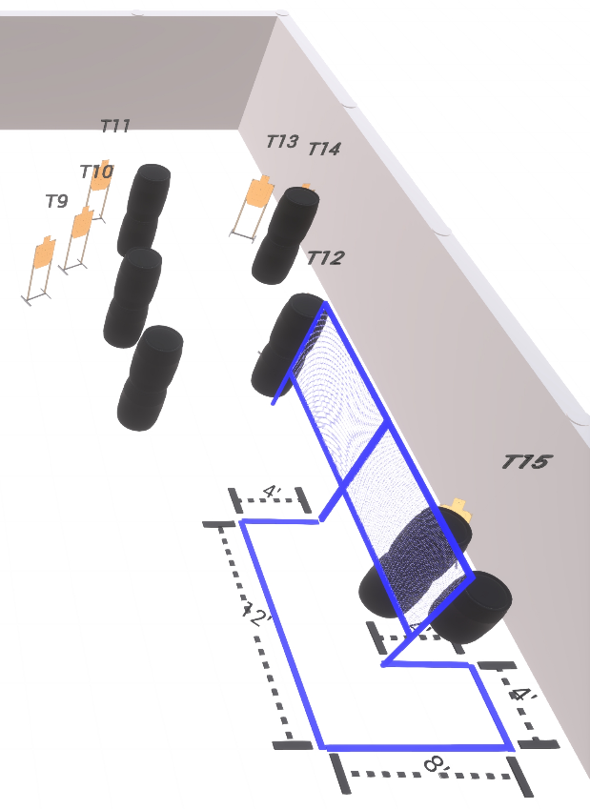
Welcome to Stage 2 - Cultivating Potential
I am _____________________________, the CRO for this stage and working with me are ____________________________________________________________.
Stage 2 is a 14 round Comstock course with 7 USPSA targets.
Start position is feet straddling the start stick with toes touching rear fault line.
Handgun is loaded and holstered, with wrists below belt.
PCC is loaded with buttstock touching the belt.
At the audible start signal, engage all targets as available from within the shooting area.
Are there any questions?
You have 4 minutes to walk the stage.

